**TEST CASE-1 (Used Jira Format)**

**Title**:

Validate an Employee can be added on Benefits Dashboard with no discount

**Description**:

**Summary**:

This test cases validates that when an Employer adds an Employee on the Benefits Dashboard, then he will see the Employee details in the Dashboard with no discount, if the First Name does not begin with “A” or “a”.

**Features to be Tested**:

1. User Story Scenario-1
2. Benefits Dashboard
3. New Employee added
4. Benefits Cost Calculations

**Acceptance Criteria**:

User Story: As an Employer, I want to input my employee data so that I can get a preview of benefit costs.

Scenario 1: Add Employee no Discount

GIVEN an Employer

AND I am on the Benefits Dashboard page

WHEN I select Add Employee

THEN I should be able to enter employee details

AND First Name does not begin with “A” or “a”

AND the employee should save

AND I should see the employee in the table

AND the benefit cost calculations are correct

**Pre-Requisites**:

1. Have the Login page URL

<file:///C:/Users/hkapalavai/Documents/HariOldComputer-Documents/Hari/Personal%20files/City/city%20QA%20Challenge/login.html>

1. Employer Login credentials

|  |  |  |
| --- | --- | --- |
| S.No | User Name | Password |
| 1. | TestUser | Test1234 |

1. Assumptions
   1. All employees are paid $2000 per paycheck before deductions
   2. There are 26 paychecks in a year
   3. The cost of benefits is $1000/year for each employee
   4. Each dependent incurs a cost of $500/year

**Test Details**:

|  |  |  |  |  |
| --- | --- | --- | --- | --- |
| **S.No.** | **Test Step** | **Expected Result** | **Status** | **Defects** |
| 1. | Login to the Paylocity login page with the provided Username and Password details. | User is successfully logged in as expected. | Passed |  |
| 2. | Validate Benefits Dashboard Login Page. | The Benefits Dashboard page is displayed after User logs in as expected. | Passed |  |
| 3. | Validate “Add Employee” on Benefits Dashboard. | Add Employee is displayed on Benefits Dashboard as expected. | Passed |  |
| 4. | Click on “Add Employee” button. | A separate popup message “Add Employee” is displayed as expected. | Failed | Defect -1 It displays as “Add Employee & His dependents” instead of “Add Employee”. See screenshot provided below. |
| 5. | Do not enter any Employee details. Click on the Close button. | The popup message box closes as expected. No Employee data is added to the Benefits Dashboard Table as expected. | Passed |  |
| 6. | Click again on “Add Employee” button. | A separate popup message “Add Employee” is displayed as expected. | Failed | Defect -1 It displays as “Add Employee & His dependents” instead of “Add Employee”. See screenshot provided below. |
| 7. | Enter the Employee First Name that does not begin with “A” or “a”. | Employee First Name is entered as expected. | Passed |  |
| 8. | Enter the Employee Last Name. | Employee Last Name is entered as expected. | Passed |  |
| 9. | Enter the Number of dependents. | Number of dependants are entered as expected. | Passed |  |
| 10. | Click on the Save button. | 1. Employer is able to click on the Save button as expected. 2. The popup message is closed as expected. 3. The Employee is added to the Benefits dashboard Table as expected. | Failed | Defect -2 “Submit” button is displayed instead of “Save” button. See screenshot provided below.  Defect-3 The ID of the second Employee is same as the First Employee. See screenshot provided below. |
| 11. | Validate the Benefits Dashboard. | 1. The Employee is added to the Benefits dashboard Table as expected. 2. The Employee First Name and Last Name are inserted correctly. | Failed | Defect -4: The Employee First Name and Last Name got reversed in the Employee Dashboard. |
| 12. | Validate the Benefit Cost Calculations does not show discount.  Benefit Cost per week =  [1000 + (N *500)] x Y /26  Where N = number of dependants  Y= 1 if the Employee First Name does not start with “A” or “a” otherwise Y = 0.9 | The Benefits Cost Calculations are calculated correctly as expected. | Passed |  |
| 13. | Refresh the webpage by clicking on the refresh icon on the toolbar. | The Employee added earlier is still displayed on the Benefits Dashboard. | Failed | Defect-5 The Employee added earlier is not displayed on the Benefits Dashboard after the User clicked Refresh. See screenshot provided below. |

**Defects:**

**Defect -1**:

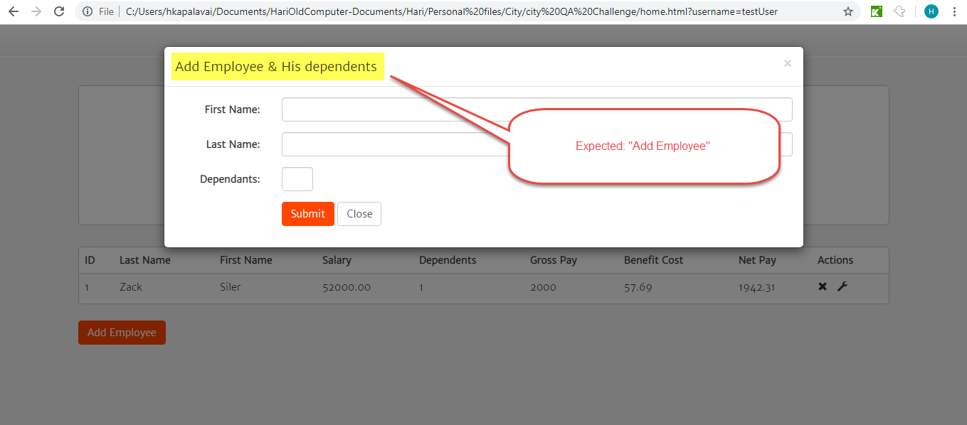

**Defect -2**

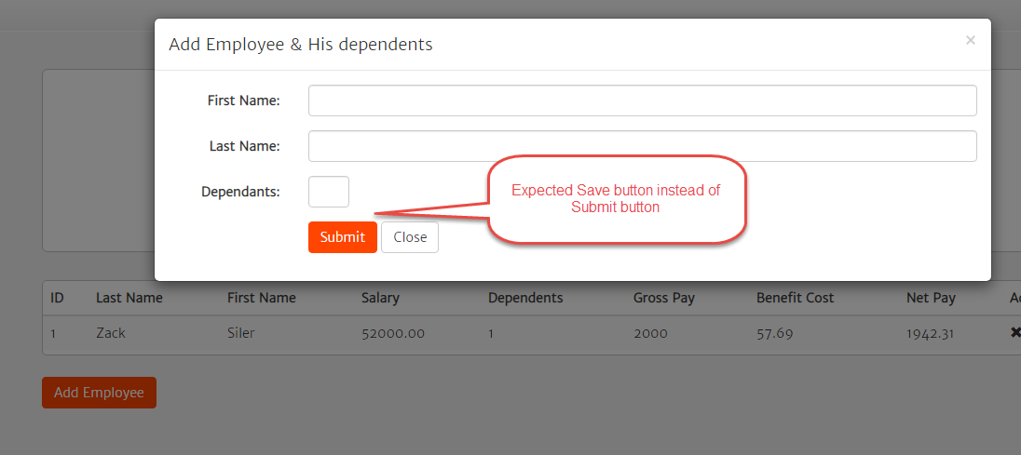

**Defect-3**

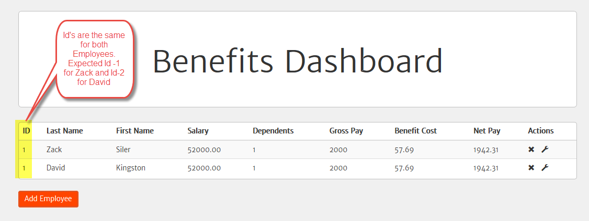

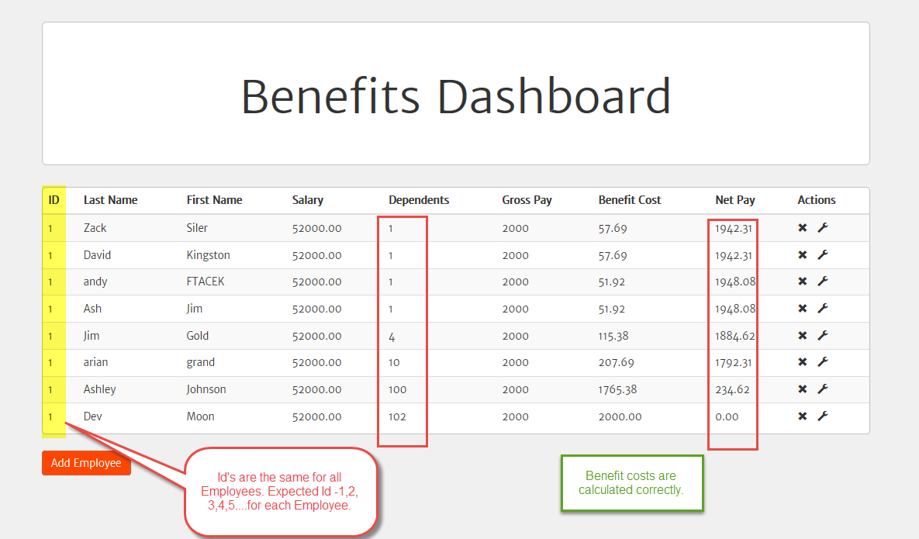

**Defect -4**

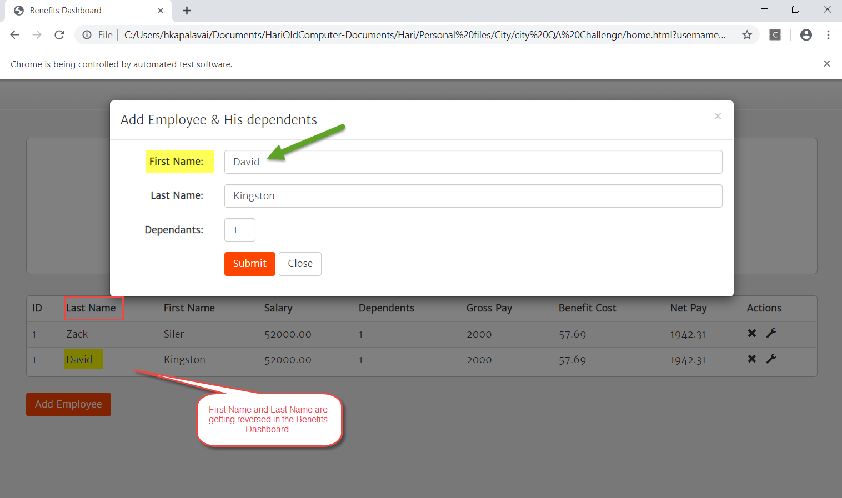

**Defect -5**

